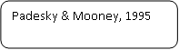

Behaviour
Situation
Thoughts
Emotions
Physical

